PW201A-How to change the wireless password and SSID
Product line: Wireless power line question category: wireless settings

- Connect PW201A to your computer by a cable.
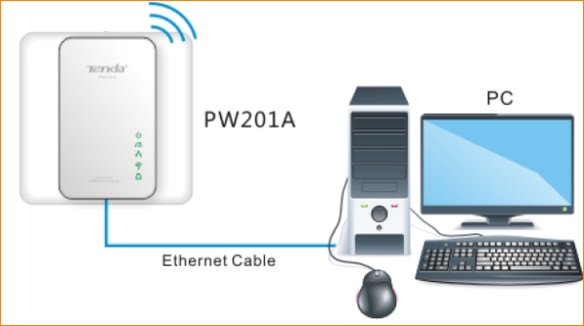
2.Set a static IP for your computer as the following picture.
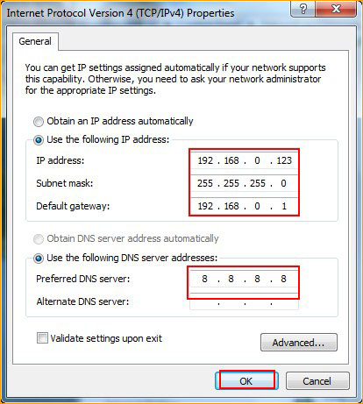
Click here to see the whole process.
- Login to the setup page of PW201A by typing 192.168.0.254 in the address bar of your web browser.
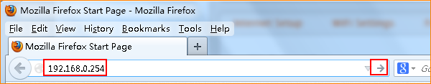

4. Input admin, admin to login.
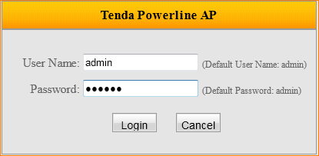

- Change the wireless password, click OK, and then click Advanced to go into the advanced setting page.
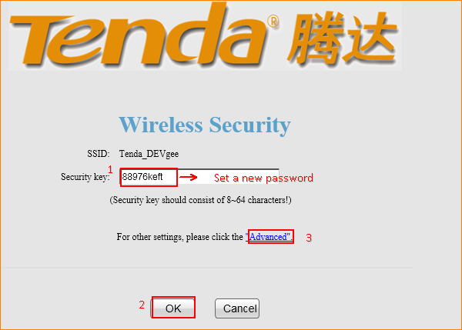

- Change the SSID (Wireless Network Name).

